iPad Apps for Learners with Dyslexia/ Reading and Writing Difficulties
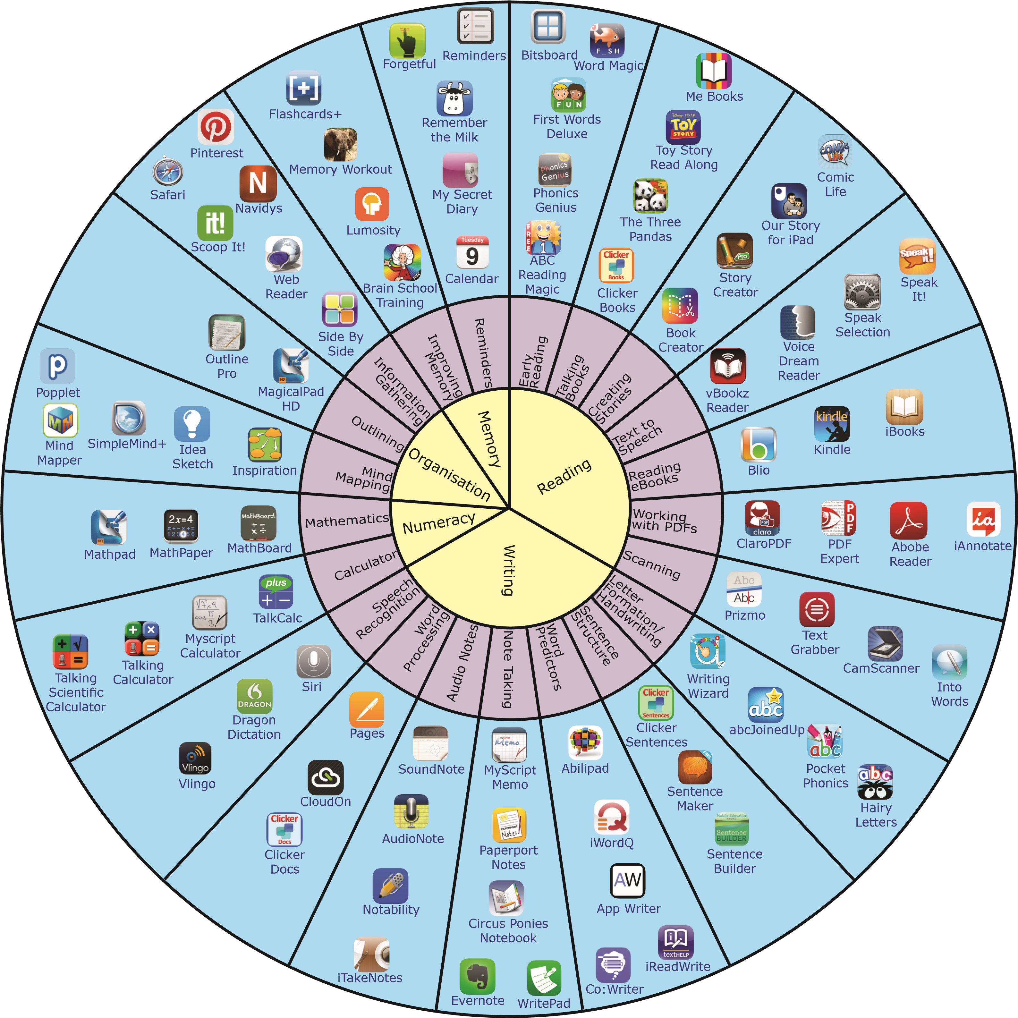
Dyslexia Indicator Apps
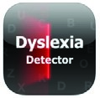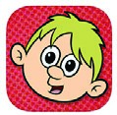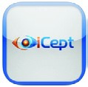
Dyslexia Detector What is Dyslexia? iCept

Dyslexia Indicator apps don’t fit into the ‘wheel’, but are definitely worth knowing about. These apps (particularly Dyslexia Detector and ‘What is Dyslexia?’ do not provide formal screening tests, but give an indication that a learner MAY have dyslexia and that this should be investigated further.
Many iPad apps are available to support learners with reading and writing difficulties. This ‘Wheel of Apps’ is not comprehensive, but attempts to identify relevant apps and to categorise them according to some of the difficulties faced by people with dyslexia.
Note that some apps address a range of difficulties. In order to save space, we have decided not to place individual apps into multiple categories, but have placed them according to a single category that is particularly relevant to the app.
There will be a far more comprehensive guide to apps for dyslexia and how to use them in a forthcoming book from CALL Scotland. This will be available as a printed book and as a free download early in the New Year from: http://www.callscotland.org.uk/Resources/Books/
This ‘Wheel of apps’ for dyslexia is inspired by previous visual app representations:
- The Padagogy Wheel - Allan Carrington
- Mobile Learning with Bloom’s Taxanomy & the Padagogy Wheel - Cherie Pickering & Amanda Pickering • Apps for Students with Autism Spectrum Disorders - Mark Coppin.
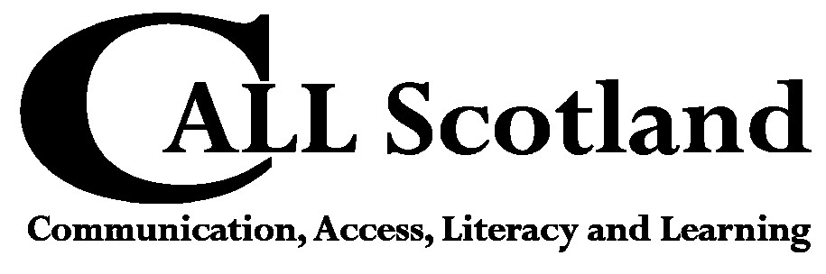
These representations are available from various web sites, but can all be downloaded from: http://apps4stages.wikispaces.com/AppWheels.
Version 1.0, November 2013 CALL Scotland, The University of Edinburgh.
An electronic version of this chart can be downloaded from: http://bit.ly/1gqOszG

